RESPONSIVENESS SUMMARY
2020 Water Quality Standards Triennial Review
April 15, 2021

- Public Notice
- Comments and Division of Water Quality Responses
- Comments-as received
- Updated Standards Tracking Worksheets
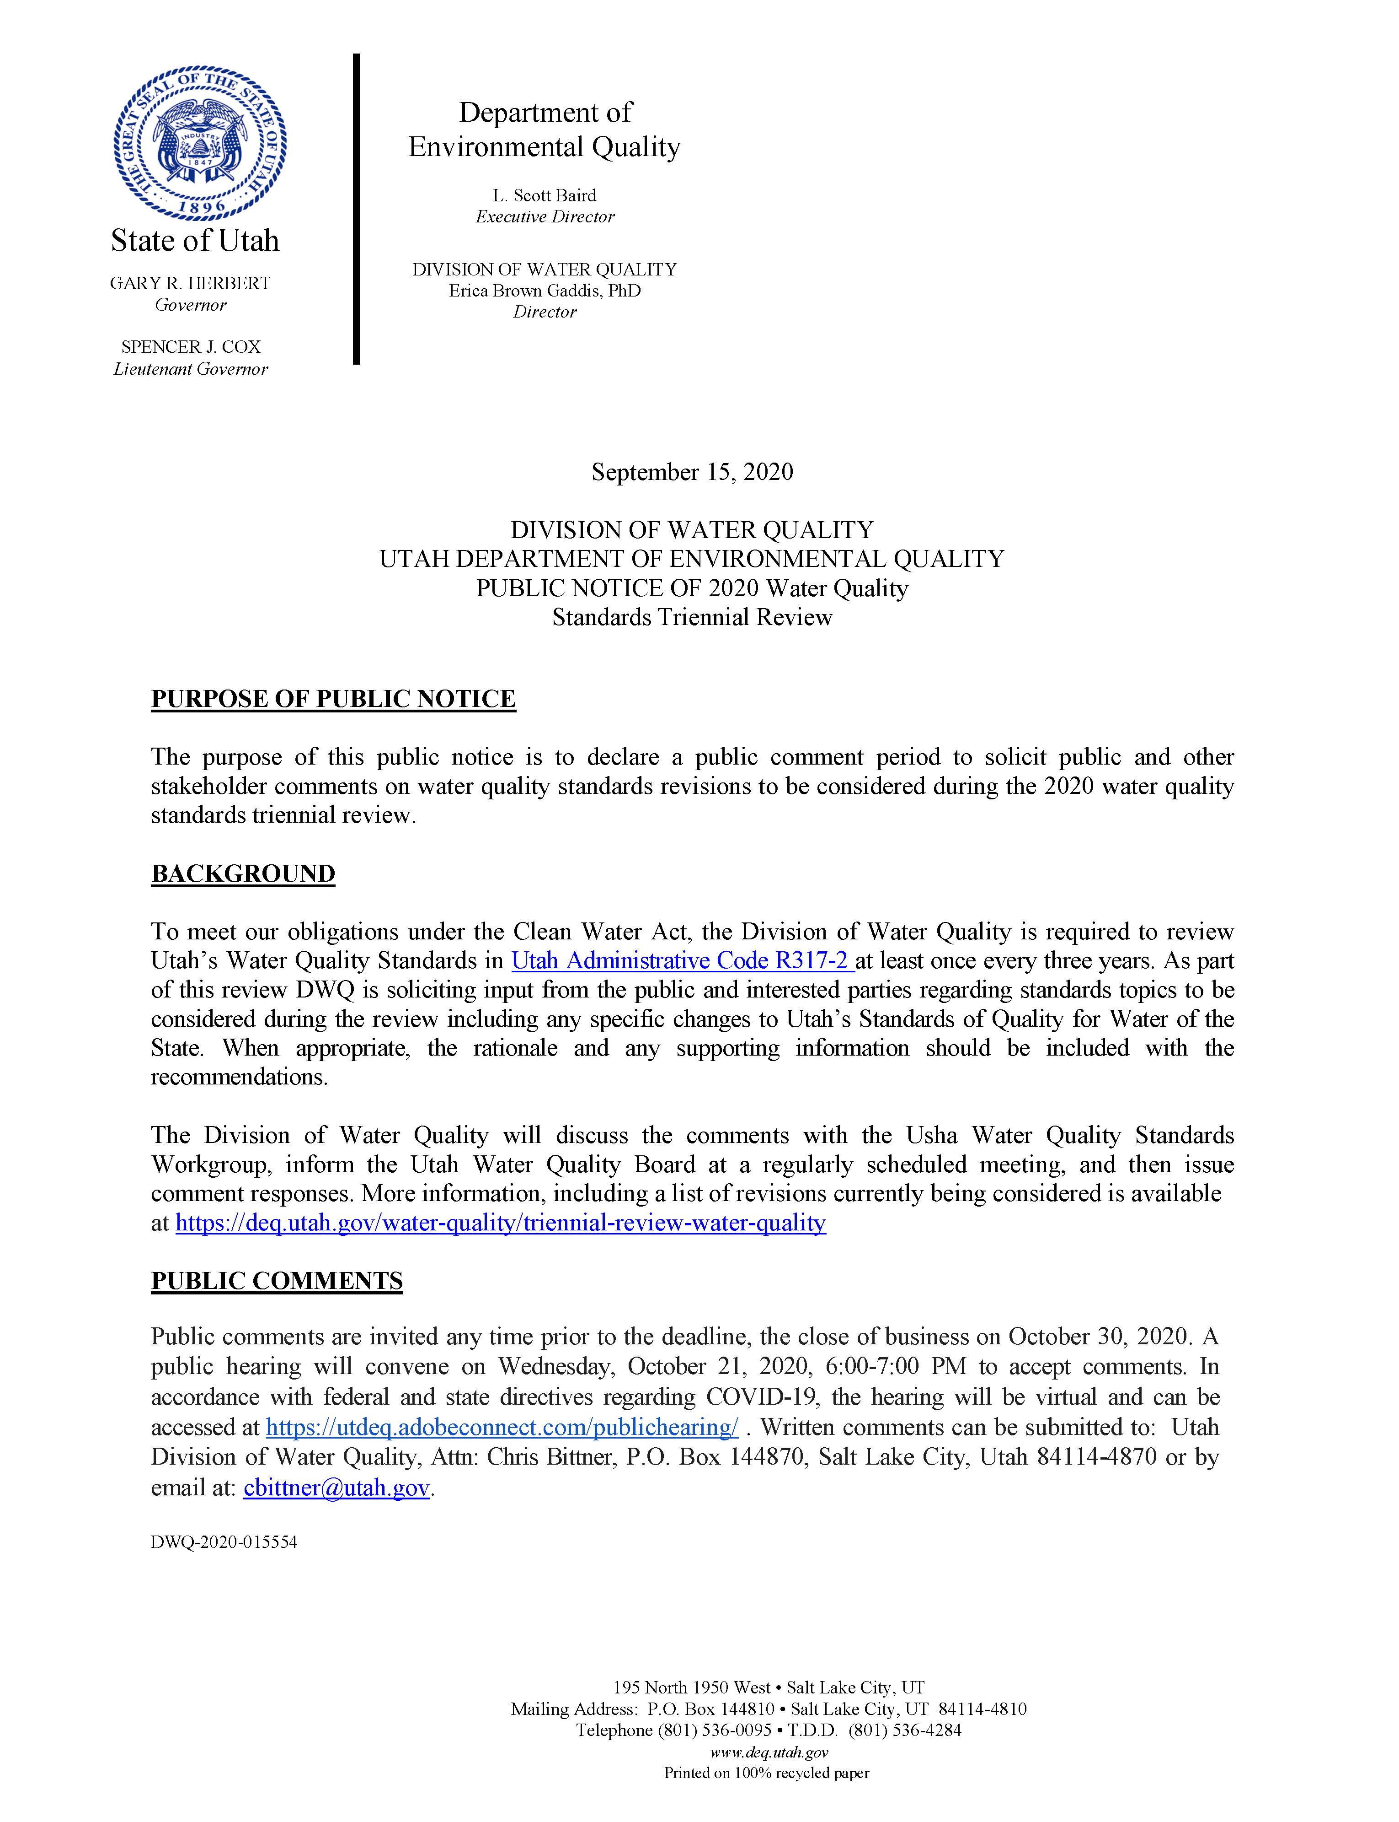

- Comment: Utah should consider adopting “hold public hearings” language into the existing R317-2-1.C.
Response: Consistent with federal and state requirements, DWQ convened a public hearing for the 2020 Triennial Review. In addition, DWQ also accepts and considers recommendations for modifying or adopting new standards outside of the Triennial µReview process. DWQ reviewed the public hearing requirements in 40 C.F.R. § 131.20(a) and concluded that no changes are necessary because R317-2-1.C. is consistent with these requirements as noted in the following (emphasis added):
“The water quality standards shall be reviewed and updated, if necessary, at least once every three years. The Director will seek input through a cooperative process from stakeholders representing state and federal agencies, various interest groups, and the public to develop a preliminary draft of changes. Proposed changes will be presented to the Water Quality Board for information. Informal public meetings may be held to present preliminary proposed changes to the public for comments and suggestions. Final proposed changes will be presented to the Water Quality Board for approval and authorization to initiate formal rulemaking. Public hearings will be held to solicit formal comments from the public. The Director will incorporate appropriate changes and return to the Water Quality Board to petition for formal adoption of the proposed changes following the requirements of the Utah Rulemaking Act, Title 63G, Chapter 3.”
- Comment: Utah should adopt the requirement that an explanation be provided if Utah is not adopting new or revised criteria for which EPA has published new or updated Clean Water Act (CWA) section 304(a) criteria.
Response: DWQ has and will continue to meet this federal requirement. Adding this requirement to Utah’s water quality standards is unnecessary because the requirement exclusively affects DWQ.
- Comment: Utah should adopt a provision in the standards to authorize compliance schedules.
Response: DWQ agrees and anticipates recommending an authorizing provision to the Water Quality Board during this Triennial Review cycle.
- Comment: Utah should review EPA’s CWA Section 304(a) 2013 updated criteria for ammonia and revise Utah’s existing criteria if appropriate.
Response: DWQ agrees and continues to make progress implementing EPA’s 2013 recommendations. In 2017, DWQ published the Utah Implementation Guidance for the 2013 USEPA Ammonia Criteria for the Protection of Aquatic Life that includes a schedule for adoption. In 2019, the Water Quality Board adopted site-specific ammonia criteria for a segment of the Jordan River based on the EPA’s 2013 recommendations. DWQ has reviewed recent toxicity data relevant to Utah unionid mussel species and is recalculating the unionids-present criteria. DWQ anticipates updating the implementation guidance in 2021 and recommending updated ammonia criteria to the Water Quality Board by 2024.
- Comment: Utah should review EPA’s CWA Section 304(a) 2018 updated criteria for aluminum and revise Utah’s existing criteria if appropriate.
Response: The 2018 criteria require measurements of dissolved organic carbon and DWQ does not routinely monitor for dissolved organic carbon. DWQ is evaluating including dissolved organic carbon as a routine monitoring parameter. The additional costs of these analyses have to be considered in the context of a limited monitoring budget.
Aluminum effluent concentrations in permitted discharges don’t currently demonstrate reasonable potential and also would be unlikely to demonstrate reasonable potential under the 2018 criteria. Some Utah waters are designated as impaired under the existing criteria and these impairments may be resolved by adopting and reassessing using the 2018 criteria.
Assuming minimal impacts to DWQ’s permitting and assessment programs, DWQ anticipates proposing criteria based on the EPA 2018 criteria to supplement the existing aluminum criteria during this Triennial Review cycle. When representative dissolved organic carbon data are available, the updated criteria will supersede Utah’s existing criteria. When representative dissolved organic carbon data are not available, Utah’s existing criteria will continue to apply.
- Comment: The EPA continues to recommend that Utah review its existing iron criterion for consistency with EPA’s CWA § 304(a) criteria recommendations. Utah’s aquatic life criterion for iron is currently expressed as dissolved when EPA’s recommendation is 1,000 µg/L total recoverable iron. It is important to express the criterion as total recoverable given the toxicity of iron hydroxide and ferric oxide (iron precipitates or floc) to benthic organisms and the reduction of suitable spawning habitat due to excessive iron floc. We are not aware of any data or analyses to support that 1,000 µg/L as dissolved iron is protective of aquatic life. Therefore, we suggest that Utah revise the existing iron criterion to total recoverable to account for the toxicity that results from precipitated iron.
Response: DWQ committed to reviewing the iron criteria for the 2017 Triennial Review. EPA’s most recent iron criteria recommendations are based on the 1986 “Gold Book”. EPA recommendations for implementing the iron criteria as total recoverable are unclear as contrasted with e.g., arsenic and lead that are explicitly recommended as total recoverable. EPA’s 1986 analyses focus on both the ferrous (usually soluble) and ferric (practically insoluble) forms:
“The ferrous, or bivalent (Fe++) and the ferric, or trivalent (Fe+++) irons, are the primary forms of concern in the aquatic environment, although other forms may be in organic and inorganic wastewater streams. The ferrous {Fe++) form can persist in waters void of dissolved oxygen and originates usually from groundwaters or mines when these are pumped or drained. For practical purposes the ferric (Fe+++) form is insoluble. “
DWQ is aware that precipitated iron can adversely affect aquatic life, especially benthic organisms. However, DWQ concludes that the existing programs along with the existing iron criteria are protective of aquatic life. Significant effort and research would be required to update Utah’s iron criteria and no clear need has been identified to warrant these efforts.
Utah is obligated to protect the uses for iron but numeric criteria are optional (CWA Section 303(c)(2)(B) and 40 CFR § 131.11). Based on the currently available information, Utah’s current criteria and implementation procedures are protective of the aquatic life uses. Permit effluent limits are based on 1,000 µg/L total recoverable iron because no dissolved-to-total recoverable concentrations translator is specified.
Utah also routinely assesses water quality using benthic macroinvertebrates. Benthic macroinvertebrates are expected to be sensitive to any adverse effects from iron flocculation. Locations where the existing criteria aren’t sufficiently protective would be identified by the biological assessments and addressed through the total maximum daily load program.
- Comment: Utah should review EPA’s CWA Section 304(a) 2016 updated criteria for selenium and revise Utah’s existing criteria if appropriate.
Response: DWQ continues to make progress with reviewing EPA’s 2016 recommendations for selenium criteria. This progress includes:
- Compiling the existing data for Utah fish tissue selenium concentrations;
- Reviewing Utah’s existing water concentration data including the limitations of the analytical methods;
- Compiling a list of Utah fish species;
- Developing a list of Utah fish species recommended for tissue monitoring;
- Developing options for fishless waters;
- Reviewing and commenting on the draft EPA implementation guidance;
- Reviewing the California performance-based selenium standards;
- Identifying potential implementation issues with UPDES permits; and,
- Review of Idaho recalculated selenium criteria for potential application to Utah.
DWQ anticipates compiling this information in an implementation guidance within the next 3 years. The guidance will include a schedule for adoption and specific milestones. An important component of the guidance is requirements for developing site-specific translators to support the adoption of performance-based criteria.
- Comment: Utah should review EPA’s CWA Section 304(a) 2001 criteria for methylmercury and revise Utah’s revise Utah’s water quality standards as appropriate.

Response: DWQ continues to monitor mercury concentrations in fish and consumption advisories are issued when concentrations exceed the EPA methylmercury criterion of 0.3 mg/kg. Utah’s mercury water criterion is 0.012 µg/L and is based on preventing mercury from accumulating in fish to concentrations unsafe for humans. While Utah’s existing standards and implementation procedures are protective of the designated uses, the fish-tissue methylmercury criterion will be recommended for adoption during this Triennial Review cycle t0 ensure consistency with federal requirements.

- Comment: Utah should review EPA’s CWA Section 304(a) 2019 recreational criteria for microcystin and cylindrospermopsin and revise Utah’s revise the water quality standards as appropriate.

Response: DWQ has used similar concentrations of microcystin and cylindrospermopsin for assessing water quality under the Narrative Standards and recommending health advisories. DWQ is currently updating Utah’s hazardous algal bloom program. As part of this update, DWQ will determine how and when the 2019 criteria will be adopted.

- Comment: For a pollutant for which the EPA has not published a recommended CWA § 304(a) criterion for "water + organisms" and for which the EPA has promulgated a Maximum Contaminant Level Goal (MCLG), the EPA generally recommends the MCLG for noncarcinogenic pollutants, or a criterion derived by recalculating the MCLG at an acceptable cancer risk level. The EPA does not recommend that the MCL be used where consideration of available treatment technology, costs, or availability of analytical methodologies has resulted in a MCL that is less protective than a MCLG. The EPA recommends that UDWQ review the criteria in Table 2.14.6 that are based on a MCL to ensure consistency with the recommendations above.
Response: Utah recently expended a significant amount of effort updating over 100 human health criteria in accordance with the EPA 2015 updates. These criteria are assigned to protect the Class 1C use. The Class 1C use, protected for domestic purposes with prior treatment by treatment processes as required by the Utah Division of Drinking Water (UAC R317-2-6), is a Utah-specific use. The EPA CWA Section 304(a) criteria human health criteria are clearly protective of the Class 1C use because they assume direct human consumption of the water and also include consumption of fish. The criteria listed for the Class 1C use in Table 2.14.1 of UAC R317-2-14 are in some cases based on the Safe Drinking Water Act maximum contaminant levels (MCLs). The MCLs are also clearly protective of the Class 1C use because under the Safe Drinking Water Act, MCLs are at the point of consumption whereas DWQ applies these criteria to Utah surface waters prior to any treatment. DWQ continues to coordinate with the Utah Division of Drinking Water to ensure that Utah’s Class 1C surface waters are protected. As resources permit, DWQ will work with EPA to address specific human health criteria that don’t meet federal requirements.
- Comment: EPA recommends that Utah prioritize making the necessary final steps to draft and adopt water quality standards protective of its wetlands ecosystems.
Response: As noted by the comment, DWQ made significant progress with developing wetland mapping tools, sampling standard operating procedures (SOPs) specific to Utah’s wetland types, assessment tools, and characterization of the highest attainable condition for impounded wetlands. However, near future progress to promulgate wetlands standards will be inhibited by the loss of EPA Wetlands Program Development Grant. DWQ is evaluating how this loss will affect the wetlands program long term. In the interim, DWQ will continue to work on protecting wetlands in coordination with the Utah Division of Natural Resources.
- Comment: EPA recommends continued dedicated efforts to develop water quality criteria applicable to portions of GSL. We recommend that Utah continue this work so that in the near future the existing uses in GSL can be fully protected under 40 C.F.R. § 131.10(i) and 131.11.
Response: DWQ appreciates EPA’s continued technical support for these efforts. By the next Triennial Review, DWQ anticipates compiling the newly developed information in an update the to the 2014 Great Salt Lake Water Quality Strategy for deriving criteria. An update to the Strategy provides a forum for stakeholders, including EPA, to support and participate with these efforts.

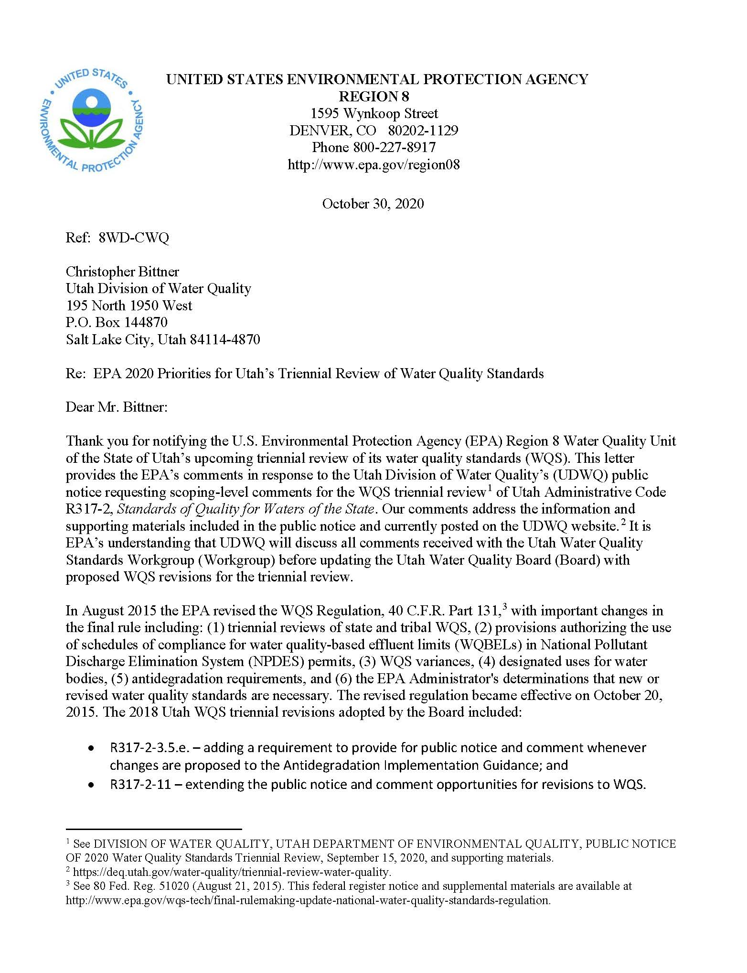
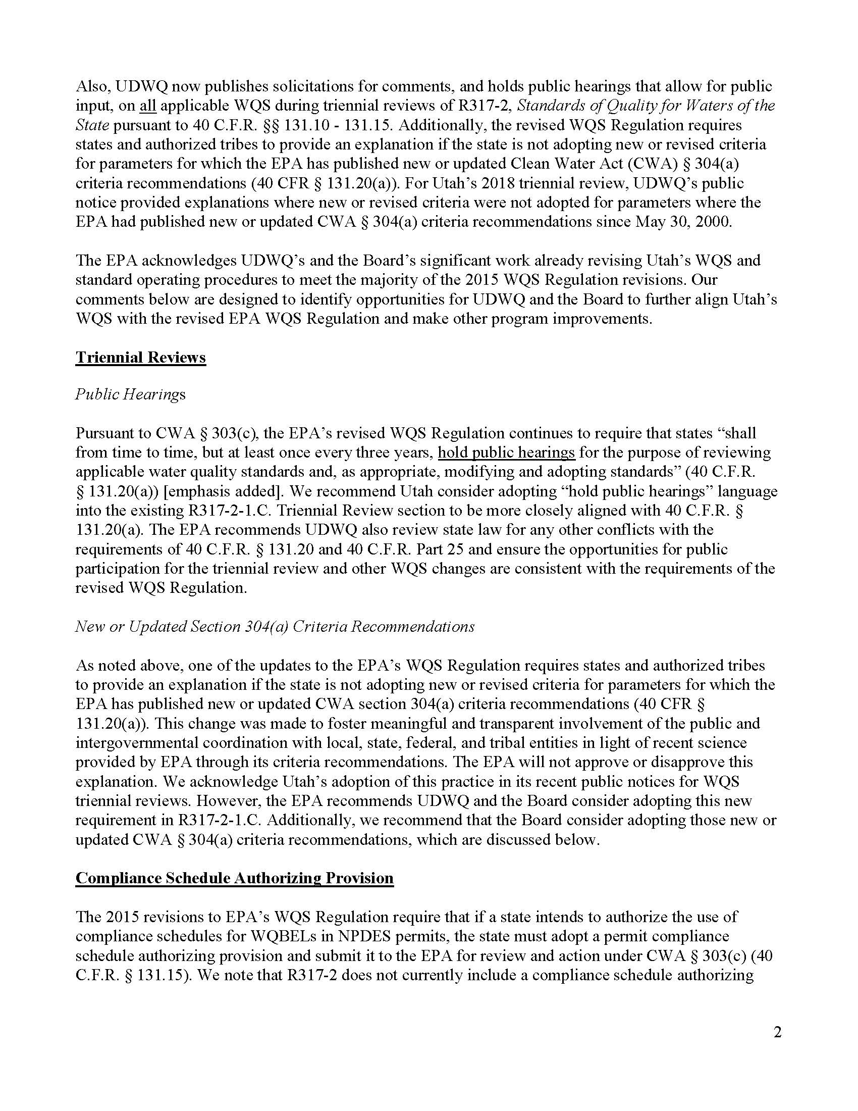
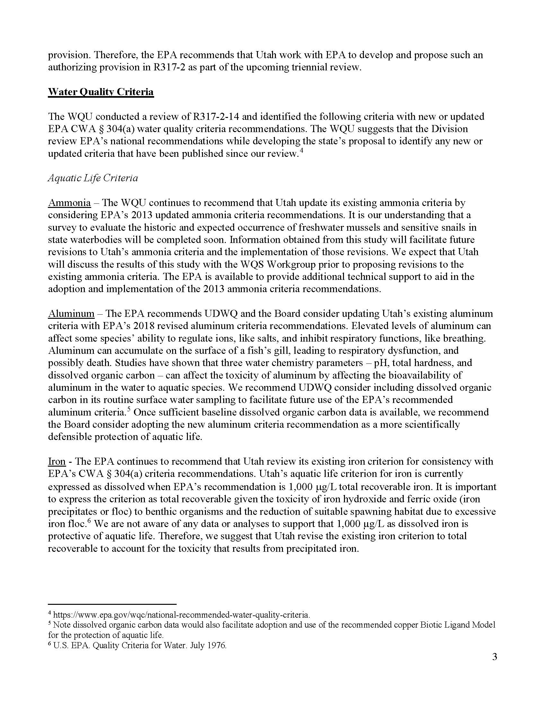
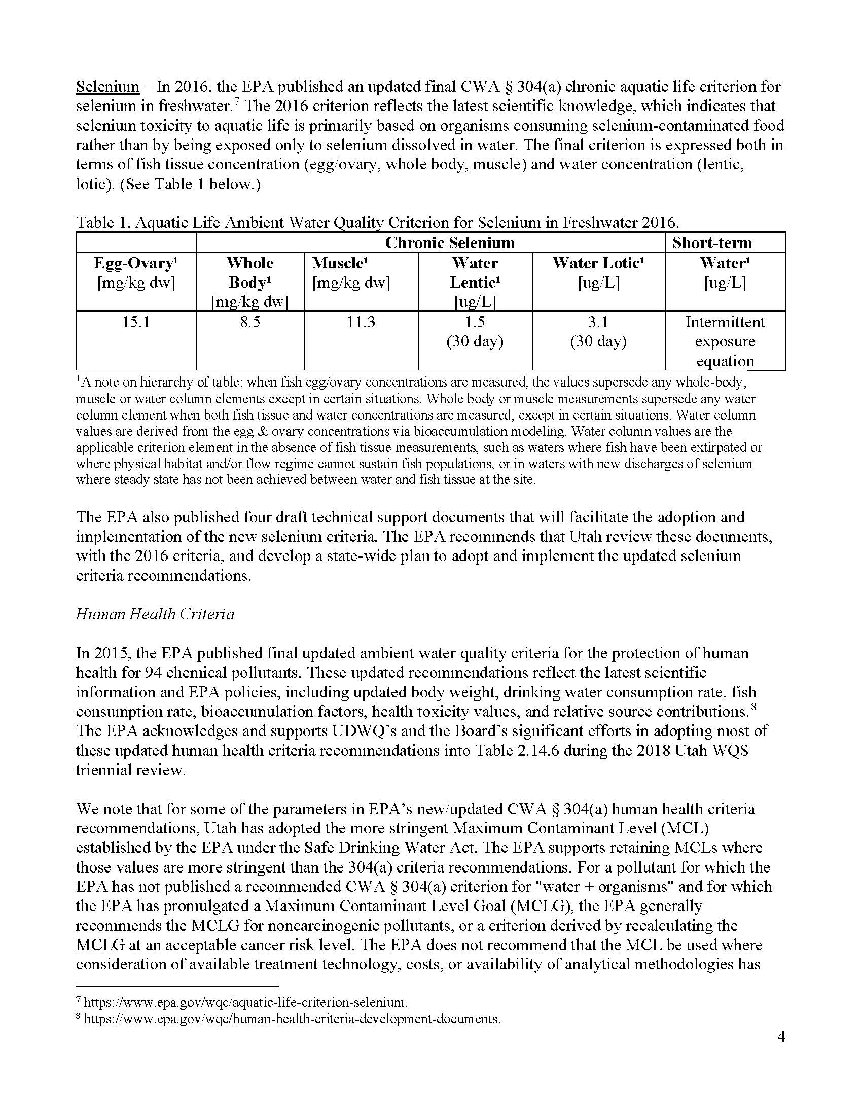
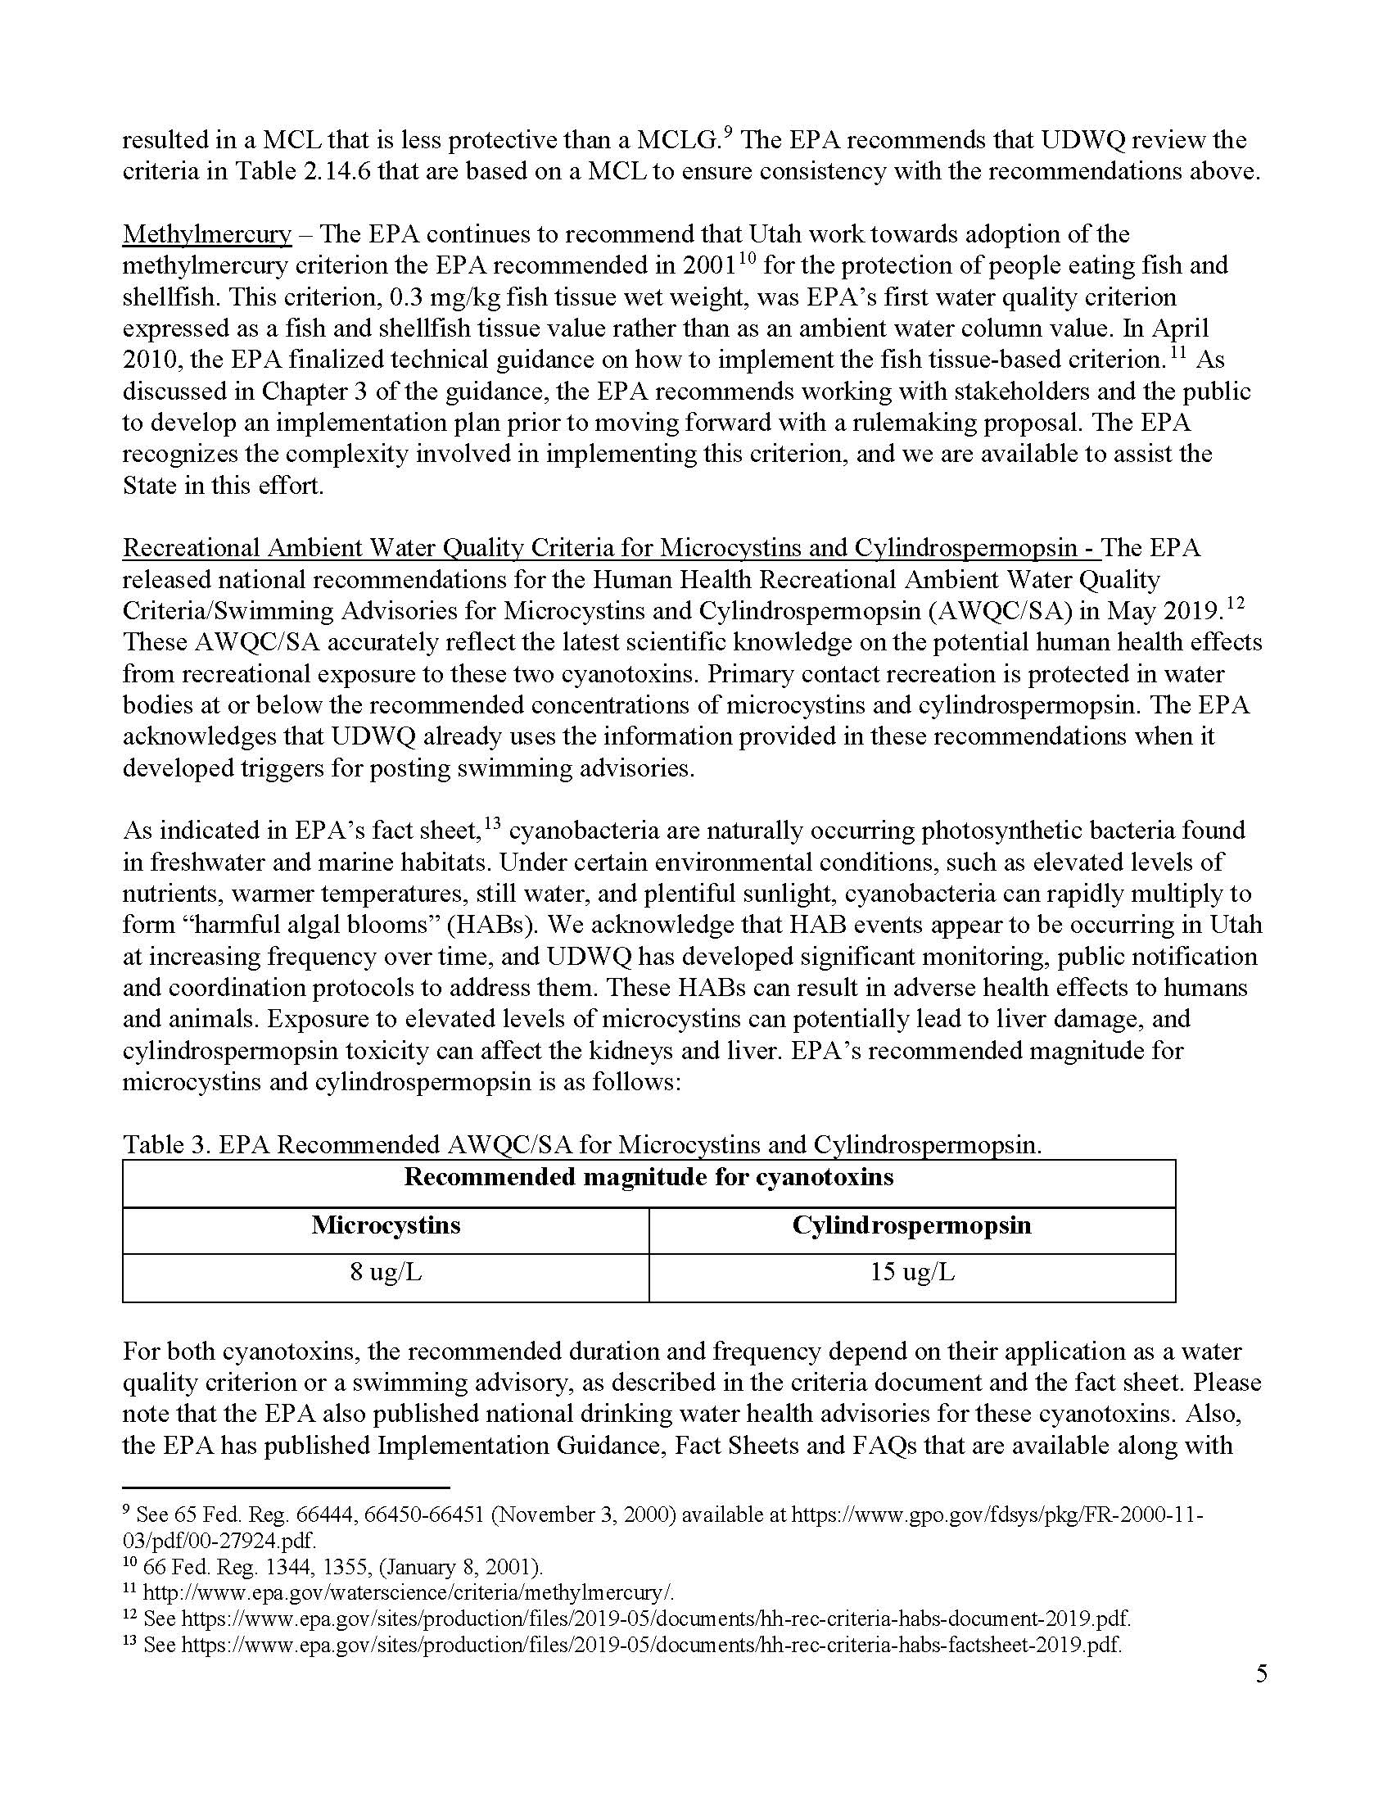
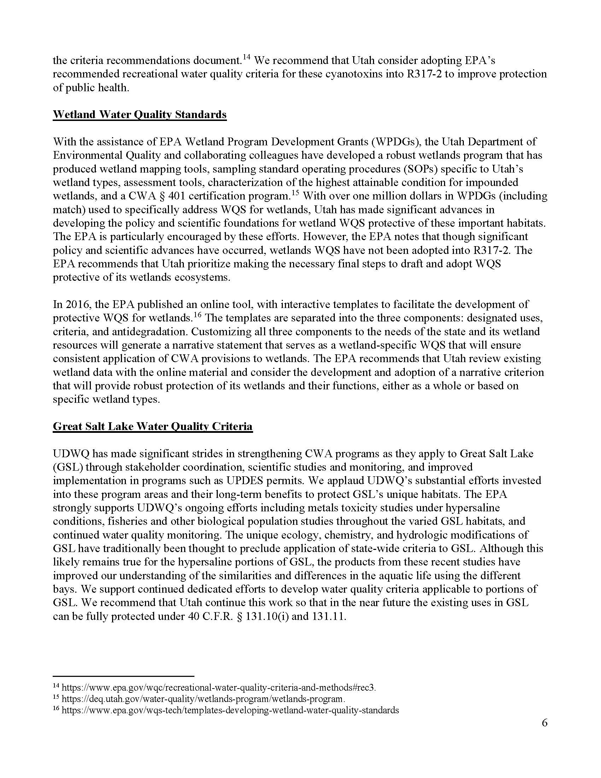
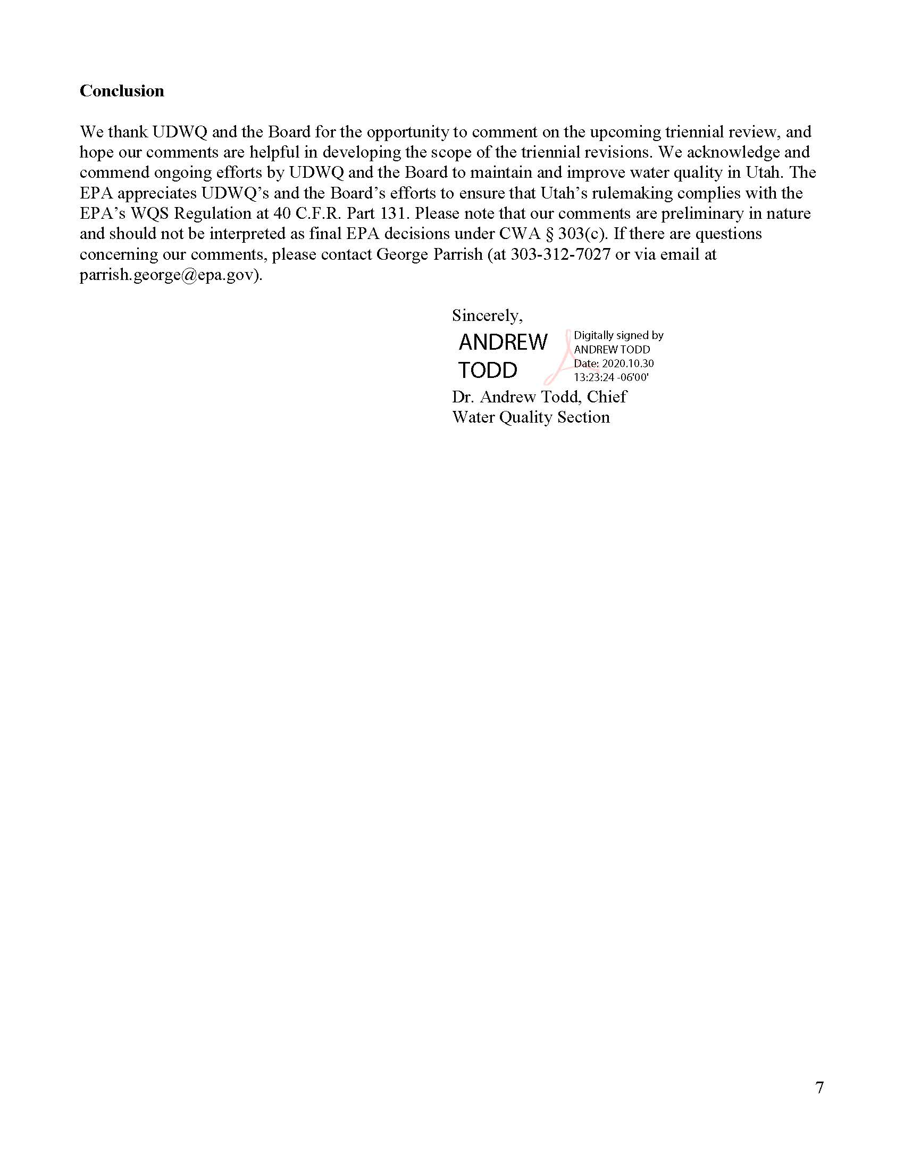
Note: No Triennial Review comments were received at the October 21, 2020 Public Hearing
Priority | Standards Issue | Discussion | 2022 Goal
1 | Utah Lake Nutrient Criteria | The Utah Lake Nutrient criteria are being developed as part of a multi- year effort using the steering committee and expert panel paradigm. | Complete studies to support  development of numeric criteria.
2 | Current DO criteria not attainable at high elevation | Utah's dissolved oxygen criteria are not achievable at higher elevations.  This can result in false-positive impairment decisions and impractical permit limits. | Propose revised standard to Water Quality Board
3 | Compliance Schedule | Per federal regulations, States must have an authorizing provision in the  water quality standards if compliance schedules are used for NPDES permits. | Propose authorizing  provision to Water Quality Board
4 | EPA 2001 Methylmercury Criteria | The fish tissue criterion should be added Table 2.14.6 and the water criterion moved from Table 2.14.2 to Table 2.14.6. The water criterion is based on protecting fish from accumulating mercury to unsafe levels for human consumption. The fish-tissue criterion will have primacy. Adding the fish tissue criterion will primarily affect assessments and assessment methods need to be developed to address implementation. Waters with current fish consumption advisories will potentially be impaired. | Propose revised standards to Water Quality Board
5 | EPA 2013 Ammonia Criteria | The 2013 EPA criteria are more stringent than Utah's current criteria if  unionid mussels are present. Utah has 2 unionid species but toxicity tests weren't available for these specific species when EPA updated the criteria. Testing was recently conducted for these 2 species (and 1 additional species) in California. Recalculating the 2013 EPA criteria using the California toxicity data results in unionids-present criteria for Utah that are similar to Utah's existing criteria which will decrease the impacts of the new criteria. | Update 2017 implementation guidance and then propose criteria to Water Quality Board
6 | EPA 2018 Aluminum Criteria | Currently, the 2018 EPA-approved biotic ligand model (BLM) may be applied as site-specific criteria. Under most water quality conditions in Utah, the BLM results in a less stringent criteria than the existing hardness- and pH-based criteria. The BLM will take precedence over the existing criteria when the data to support the BLM are available. Although BLM criteria are more refined than the existing hardness-based criteria, they require more analytical data and are more complex to implement.  Aluminum is not a priority or toxic pollutant and discharges don't currently demonstrate reasonable potential. However, the BLM will provide a more efficient alternative to the TMDL process for resolving impairments.  Adding the BLM to the existing criteria is anticipated to be simple. If the  process or impacts are more complex than anticipated, updating the aluminum criteria may be tabled. | Propose criteria to Water Quality Board
7 | 2016 Selenium Criteria | The 2016 EPA criteria is hierarchal with the fish tissue criteria superseding water column criteria. The water criteria are more stringent than Utah's current criteria and selenium is common in Utah surface and waste waters. More stringent selenium criteria will impact existing discharge permits that may require changes to treatment processes.  Idaho recently applied the species deletion procedure to EPA's criteria resulting in less stringent criteria. This process may be appropriate to apply to Utah. The Idaho criteria provide a modest increase in the water- based criteria (3.4 vs 3.1 vs Utah current 4.6 ug/L) and a larger difference  in the fish muscle criteria (13.1 vs 11.3 mg/kg). | Prepare implementation guidance that compiles existing data, includes recommendations for developing site-specific translators, and a schedule for adoption. The implementation guidance will include public review.
8 | Great Salt Lake numeric criteria | The 2014 Great Salt Lake Water Quality Strategy should be updated.  Based on the outcomes of testing for brine shrimp and brine flies, the most sensitive use for Gilbert Bay aquatic life for inorganic pollutants will likely be birds. An aquaculture use with criteria based on the brine shrimp bioassays could be added for Gilbert Bay. Based on the compilation of species present in Bear River and Farmington Bays, freshwater criteria may be appropriate. | Update of the Great Salt Lake Strategy for deriving aquatic life use criteria (Component 1)
9 | Salinity criteria | Increased salinity is a threat to Utah's agricultural designated use and aquatic life in the arid west. Utah should investigate these threats and consider implementing programs to protect the designated uses. One option is by the adoption of additional or more refined criteria to protect these uses. Options for criteria include TDS, chloride, and conductivity. | Review existing efforts by EPA and other arid states to protect water quality for ions.

